# DISCLAIMER

This report was prepared by students as part of a university course requirement. While considerable effort has been put into the project, it is not the work of licensed engineers and has not undergone the extensive verification that is common in the profession. The information, data, conclusions, and content of this report should not be relied on or utilized without thorough, independent testing and verification. University faculty members may have been associated with this project as advisors, sponsors, or course instructors, but as such they are not responsible for the accuracy of results or conclusions.

Table of Contents

DISCLAIMER 2

1 BACKGROUND 4

1.1 Introduction 4

1.2 Project Description 4

1.3 Original System 4

2 REQUIREMENTS 5

2.1 Customer Requirements (CRs) 5

2.2 Engineering Requirements (ERs) 6

2.3 House of Quality (HoQ) 7

2.4 Functional Decomposition 8

2.4.1 Black Box Model 8

2.4.2 Functional Model 9

3 DESIGN SPACE RESEARCH 10

3.1 Literature Review 10

3.1.1 Student 1 (Saad) 10

3.1.2 Student 2 (Abdalla) 10

3.1.3 Student 3 (Abdulrahman) 10

3.1.4 Student 4 (Musaad) 11

3.1.5 Student 5 (Mohammed) 11

3.1.6 Student 6 (Abdullah) 11

3.2 State of the Art – Benchmarking 11

3.2.1 System Level State of the Art – Benchmarking 12

3.2.2 Subsystem Level State of the Art Benchmarking 13

4 CONCEPT GENERATION 19

4.1 Full System Concepts 19

4.1.1 Full System Design # 1: RC Controller with Drone 19

4.1.2 Full System Design # 2: Automatic cleaning Board 19

4.1.3 Full System Design # 3: Rotating Drone with Firefighter setup 20

4.2 Subsystem Concepts 21

4.2.1 Subsystem #1: Propellers 21

4.2.2 Subsystem #2: Motor 23

4.2.3 Subsystem # 3: Microcontrollers 26

5 DESIGNS SELECTED 29

5.1 Technical Selection Criteria 29

5.2 Rationale for Design Selection 29

6 REFERENCES 31

7 APPENDICES 33

# 1 BACKGROUND

## 1.1 Introduction

Traffic signs play an important role in controlling the traffic and reducing the accidents happens on the highway. Traffic signals indicate which lane need to stop and which traffic lane can go, while traffic signs identify where you are heading, what are the directions to the destination, speed limits define on the signs, instructions given for the prohibited things, miles to reach the destination defines, etc. Traffic signs and signals always hang at high places like poles where it can clearly see from far distance and drivers can reduce the speed for stopping or become alert and drive carefully from that point or follow the instructions define on the signs. Traffic signs always uses sharp color which can clearly see from the long distance. With all these features, traffic signs are quite important for the motorists but as the traffic signs hangs on the highways and roads openly so after sometime sign boards become dirty because of pollution and reading the signs boards become difficult and traffic signs get dim. For that situation it is necessary to clean the sign boards after some interval to make the traffic signs clear for the drivers and keep the highways safe. The contemporary issues define by this project was to clean the traffic signs, this is the first issue, second issue is that big machines use to clean the traffic signs but they block all the traffic on that route and it keep the traveler facing lot of issues, and third issue is that the device to clean the sign board must be safe to use, so safety is another problem define in this project.

This project is to design a device which can clean the traffic signs without interrupting the traffic flow. The main objectives of this project is to keep the traffic continually working, the device is safe to use and it must be failsafe.

This project interest the sponsor because of the fact that there is no such device available in the market for this purpose and it is necessary to invent such device which clean the sign boards without interfering the traffic and this thing interest the sponsor to work on. This project will be beneficial for the sponsor as sponsor can utilize the design for commercial purpose and the stakeholders like drivers, motorists, and public who travel on highways can travel safely and read the sign boards easily, it will help them in many ways during the travelling. This project is important as it will be beneficial for the public and will keep them safe.

## 1.2 Project Description

The project defines as to innovate a device that can clean traffic signs without interrupting the flow of traffic. It has to be operated remotely and it must be reliable and safe to use. It must possess the failsafe condition and the accuracy of the system must be high and it should be eco-friendly as well. During the cleaning water must not fall on the highways.

## 1.3 Original System

Our project is original system and there is no other project developed before when this project has started.

# 2 REQUIREMENTS

The project requires from the team to design a systematic device which can clean the traffic signs on the highways without disturbing the traffic flow. And the device need to be safe to operate and failsafe condition must be present in it. The team will design the device according to the given description of the project. In this chapter, the project description will describe in the form of customer requirements in tabular way, and then engineering requirements devised from the customer requirements. After that QFD will develop to define the relation between CRs and ERs and then identify the most important engineering requirement till the least engineering requirement in a sequence.

## 2.1 Customer Requirements (CRs)

Customer requirements are the project description in a tabular form which contains all the important points of the project define by the client. The purpose of making the customer requirements table is to highlight the main part of the project so that when the project will be ready it can clearly examine through the customer requirement whether the objectives of the project have achieved or not. Another reason to do the customer requirements I to understand the project because sometime the project description is not clear enough to understand the project so customer requirement helps at that time. The customer requirement for this project has been given in the table 1.

Table 1: Customer Requirements

|  |  |
| --- | --- |
| **Customer Requirements** | **Weightage** |
| Do not interrupt the flow of traffic | 9 |
| Failsafe | 8 |
| Collect Water Drops | 7 |
| Clean in short time | 6 |
| Clean without damaging the coating | 5 |
| Safe to Operate | 4 |
| Cost within budget | 3 |
| Durable and Robust Design | 2 |
| Reliable Design | 1 |

Do not interrupt the flow of traffic requirement is meeting the objective as it has asked to develop such design which cannot interrupt the traffic flow so it is directly meting the objective. Failsafe is also the highlighted point in the description so it is meeting the objective as well. Collect water drops, meets the objective as the cleanliness can perform through the water. Short time cleaning meets the objective as to perform the task in quick way according to the objective of project. Clean without damaging the coating meet the objective that state safe to use without causing any trouble, safe to operate the device meet the objective of safe to use, cost within budget is a necessary requirement because budget has given so it must be within that budget and that’s the regular objective of any design project, durable and robust design meet the objective as it is necessary for the design to be long lasting and can easily move from one place to another place so it is meeting the objective of safe to use. Reliable design meets the objective as it need to work all the time in all the conditions.

## 2.2 Engineering Requirements (ERs)

Engineering requirements are the one which developed from the customer requirements and these are the technical details about the project so that the project can develop using these physical values and these physical values can test through different procedures when the product will develop. Table 2 has shown the engineering requirements generated for this project.

Table 2: Engineering Requirements

|  |  |  |  |
| --- | --- | --- | --- |
| **Engineering Requirements** | **Target Values** | **Tolerance** | **Justification** |
| Flight Time | 20 minutes | $$± 5$$ | 20 minutes have given, 5 minutes tolerance so that it can work easily in that limit |
| Height of Flight | 20 feet | $$± 5$$ | Minimum height is 15 feet so tolerance is 5 feet above this value and target value is 20 feet |
| Water tank | 3 liter | $$± 2$$ | 3 liter of water is enough to clean board, and 2 liter of tolerance can easily work for it |
| Device Weight | 2 kg | $$± 1$$ | 2 kg of device is enough to lift up and 1 kg of tolerance to bear the extra load |
| Reliable in temperature | -10C to 40C | $$± 5$$ | High range of temperature variation can wear in this range with tolerance of 5 degrees at each point |
| Durable | 2200 GPa | $$± 200$$ | Bear the shear stress of 2200 GPa to show durability, 2200 GPA is high value so tolerance range is high as 200. |

Flight time is the time to keep the device in the air and that is necessary for the device because it takes around 10 to 15 minutes to clean a board so the range of 20 minutes flying is enough for cleaning. Height of flight is defining the height that will take off by the system and the product will fly above the defined height and if the board is lower than the 15 feet, it will not clean through this system.

Water tank carrier is basically carrying capacity of the device for the water, and this would be 3 liters which is enough to clean the boards.

Device weight is basically the weight of the device that will carry by the device itself during the flying and the weight is 2 kg maximum so it can easily lift up in the air and fly.

Reliable in temperature means the device can withstand again harsh temperature either in cold season when temperature goes below 0 degrees or in summer season when temperature goes above 30 degrees. The device must be reliable in such a range of temperature.

Durable means the device must be strong and for this purpose it should have the shear stress of 2200 GPa so that it will not easily break in any condition.

## House of Quality (HoQ)

House of Quality is a chart which describe the relationship between the customer requirements and engineering requirements through a matrix. It is a matrix form, where top side of matrix contains the engineering requirements, left column contains the customer requirements and relating each customer requirement with the engineering requirement and fil their corresponding box with the value that shows the dependency, the dependency can be high and large number will put in that else leave the box. In this way the matrix form and them calculate the absolute importance from the matrix using the weightage values and then relative technical importance for each engineering requirement. In this way the engineering requirement can enlist from the top priority to the least priority. Following figure has shown the House of Quality

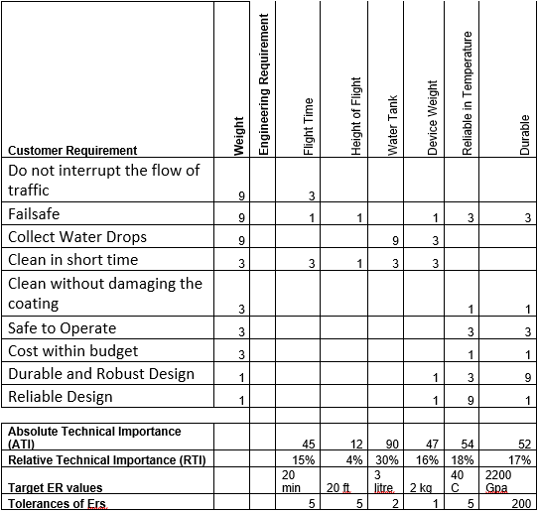

Figure 1: House of Quality (HoQ)

Results of HoQ has shown that the most important engineering requirement is water tank which need to carry with the device for cleaning purpose, and the second most important is reliable in all the weather conditions, third is durable, fourth is device weight, fifth is flight time, and sixth is height of flight.

## 2.4 Functional Decomposition

The project is to clean the traffic signs boards, and it need not to interrupt the flow of traffic as well so in that situation the functional operation of this project will consist of controller which control the main product, that product will reach near to the sign board and it will fly up in the air to clean the board and then will return to the starting point. The cleaning function will consist of a wiper, that will dip into the water and scroll that wiper over the sign board to make it clean without putting the water on the ground surface. This was the main functionality of this project, while the functional decomposition for any project consists of two types, one is the black box, and second is the functional model. The black box defines the inputs and outputs of the system without interfering inside the system, and functional model describe the complete process of the input to reach to the output. In the functional model, all the subsystem defines together.

### 2.4.1 Black Box Model

The black box model is basically a model which defines only the inputs and outputs of the system and it has nothing to do with the internal functionality of the system and that is why the name has given to it as the back box. Because what is inside the box is of no interest in black box model, it only sees what we will provide to the system and what we will get from the system. The inputs and outputs consist of material input, energy input and signal input and vice versa for the output. The black box model has shown below

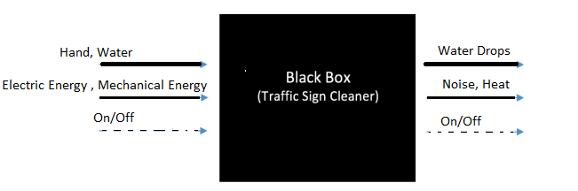

Figure 2: Black Box Model

In the above black box model, human hand and water are the materials uses as the input, hand to control the controller and water to use for cleaning, while for the energy, electrical energy and mechanical energy are using to perform the action, and the signal of the device as the input is either on or off. In the same way, output is showing that the material is water drops while cleaning, in the energy noise and heat will release, and signal is either on or off. It has helped the team in understand the project basic functionality, as through this model it is clear that we will use a controller for performing the task, some water drops will fall down on the ground as the output along with the clean sign board.

### 2.4.2 Functional Model

The functional model describes the complete functionality of the system which can expect after the product will implement. In the functional model all the subsystems will define for the project. The functional model has shown below in the figure.

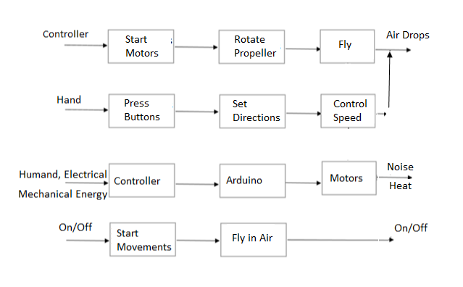

Figure 3: Functional Model

The above functional model contains the subsystems like

* Motors
* Propellers
* Arduino
* Controller

From this functional model it is easy to understand what will be the functionality of device what we will going to implement. As the complete process has described from starting the motor till the cleaning so this clears the understanding of project.

# 3 DESIGN SPACE RESEARCH

As the design project always starts with research and find the similar projects and existing projects. And then see what other people have done in this field, like search for the published article and read different designs to understand how the project can implement and which are the necessary functionalities that need to build in the project. There is a literature review which shows the other sources related to the project and describe each source with little summary. And other thing is state of the art or benchmarking, this is showing the existing the designs related the project. In this section, literature review will present and then benchmarking will present, after that existing designs will present for the full system and then existing designs will present for the subsystem of the project.

## 3.1 Literature Review

### 3.1.1 Student 1 (Saad)

Liquid stream in pressure driven frameworks, fittings, and channeling causes water driven misfortunes because of the alter of stream course and grating in the liquid. The primary outcome of the subsequent misfortunes is the expansion in the general weight inclination of the circuit. The paper is centered around the examination of valve misfortunes and the assurance of obstruction coefficients, the meaning of which relies upon the valve type. Strategies for assurance are of two kinds, for example exploratory strategies and numerical techniques. On account of test techniques, the strategies recommended by the norms and guidelines must be regarded. Scientific strategies are identified with characterizing a fitting scientific model and numerical methodology. The two techniques are applied to the ball valve and model check is performed simultaneously. The yield of the postulation is the strategy for assurance of opposition coefficients of valves with different widths and other streaming media dependent on confirmed numerical displaying.

### 3.1.2 Student 2 (Abdalla)

Windshield wipers assume a key job during unfriendly climate conditions by cleaning the downpour ceaselessly over the windshield territory and gives an unmistakable vision to the driver. The conventional framework anyway requires driver's steady consideration for controlling the cleaning speed physically. Right now control frameworks are concentrated consequently actualizing different computational devices like fluffy rationale control, neural system control and versatile neuro fluffy derivation framework (ANFIS) control utilizing MATLAB. An Intelligence based control approach is introduced so the windshield wipers can be computerized all the more successfully dependent on the control rationale calculations. It presents a novel based investigation of control calculation by actualizing the above MATLAB apparatuses and their aftereffects of each control calculation fluffy rationale, neural system and versatile neuro-fluffy deduction framework (ANFIS) were considered and contrasted with comprehend the best framework.

### 3.1.3 Student 3 (Abdulrahman)

The plan, development and testing of a solitary stage divergent siphon is introduced right now, electric engine drives the outward siphon, which draws ﬂuid (water) from a water stockpiling divider and conveys same through a ﬂow control valve to a tank. The trial results acquired shows that the tried siphon can build up a head, (H) of 30m, volumetric release, (Q) of 9m3/hr and the speed of 2900 rpm for an information intensity of 1.5HP (1.1k). The activity of the siphon was seen to be smooth with low vibration and clamor level on the siphon and engine individually, this assurance the unwavering quality of the siphon in administration.

### 3.1.4 Student 4 (Musaad)

Automatons are as of late accepting a developing consideration in both common and military divisions. In spite of their great highlights, for example, high mobility, wide assortment of utilization, and ease; battery-controlled automatons are as yet restricted as far as continuance. They can't perform long flights and determined missions. This paper proposes then an audit based conversation of the arrangements tending to this issue, including swapping laser-pillar inflight energizing and tying. Half and half force supply framework is likewise an answer of decision. Consolidating battery with various sources, for example, power device, sun oriented cells, and supercapacitor permits the framework to profit by sources points of interest and spread their confinements. Right now, paper gives a relative and basic investigation of various force supply models, in this way encouraging the exchange off in the decision of the reasonable automaton power supply framework. Experiences and suggestions for future research are likewise given.

### 3.1.5 Student 5 (Mohammed)

A structure strategy and investigation instrument of a UAV propeller dependent on Blade Element Momentum Theory (BEMT) for low-Reynolds number stream is introduced. BEMT is finished with 3D harmony execution, a post-slow down model and whirl speed contemplations to improve the exactness of the outcomes. An open-source code, JBlade, in light of BEMT is utilized to get execution bends in off-structure cases for a given propeller. At long last, the outcomes are examined for a UAV Hirrus propeller. This procedure can be utilized effectively in the starter configuration period of a UAV propeller, whose information would then be able to be utilized as contribution to an advancement strategy.

### 3.1.6 Student 6 (Abdullah)

This paper investigates the working guideline and uses of an Arduino board. This additionally investigates on how it very well may be utilized as an apparatus for study and research works. Arduino board can give a fast device being developed of VLSI test seat particularly of sensors. Principle points of interest are quick preparing and simple interface. Today, with expanding number of individuals utilizing open source programming and equipment gadgets for a long time, innovation is framing another measurement by making confounded things look simpler and intriguing. These open sources give free or for all intents and purposes low costs, exceptionally dependable and reasonable innovation. This paper gives a look at kind of Arduino sheets, working standards, programming execution and their applications.

## 3.2 State of the Art – Benchmarking

The project is to implement a system which can clean the traffic signs, so the benchmarking has done by search over the internet and find the sources which are relevant to the project. From the search different existing designs have found, but there are not much existing designs available for this concept so the existing design found were then summarized in the next section. The concept of this project is kind of new and there was not much work done in this field therefore it was even difficult to find the existing designs for the project.

### 3.2.1 System Level State of the Art – Benchmarking

For this project existing designs have found which were using for cleaning the sign boards. As state earlier there was not much work done in this field so finding the existing design for the system level was quite difficult but it has found and presented below.

#### 3.2.1.1 Existing Design # 1: VISIONCLEAN

This is an existing design which uses a big truck over which watery jet brushes uses to clean the sign boards, this is quite big truck and it can clean the traffic signs by interrupting the traffic flow. It is bigger in size and cleaning the big sign board is easy through it but for small signs it is difficult to clean with it. Also it consume lot of fuel to clean the sign boards.

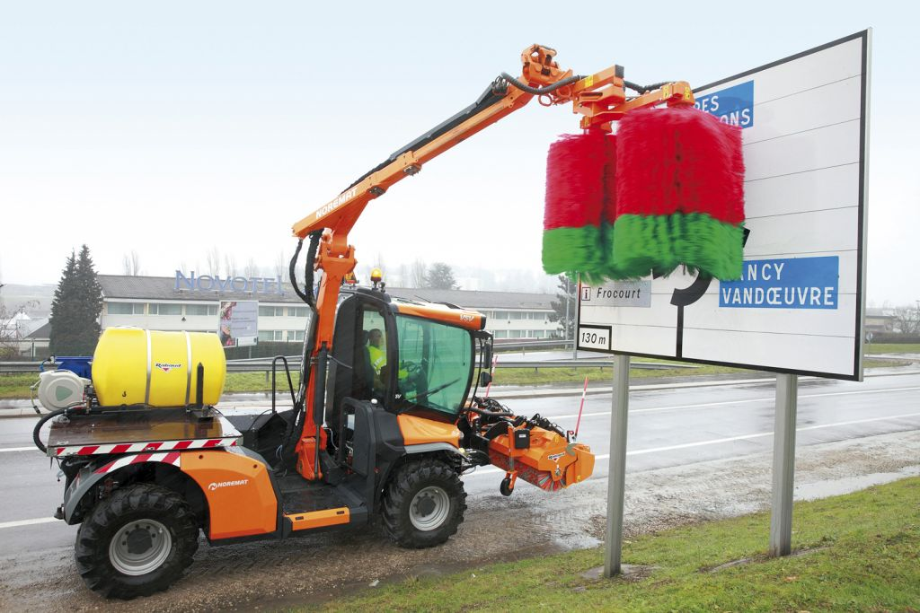

Figure 4: VISIONCLEAN

#### 3.2.1.2 Existing Design # 2: Manual Cleaning

Another way to clean the traffic signs is through the manual system, in which human do it directly using the brush. This is one of the old way and it commonly uses to clean the boards. This is Important that cleaning the signs with humans is easy rather than using the vision clean truck method. An example of manual cleaning has shown below

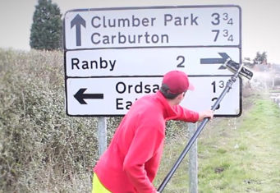

Figure 5: Manual clearing by MNA

#### 3.2.1.3 Existing Design # 3: Solar Board Cleaning

Another exiting design found for cleaning the boards, is an automatic cleaning board but it is not using in cleaning the signs, while it can use for cleaning the sign boards, it sticks over the board using the channels and then automatically move from one position to the other using the slider to clean the board as it has shown in the following figure

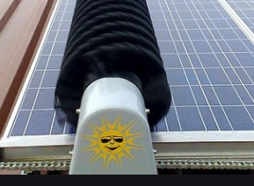

Figure 6: Automatic Board Cleaning

### 3.2.2 Subsystem Level State of the Art Benchmarking

As like the top level system benchmarking has done, there are some subsystems exists in the project which are useful and important for the project. There are some existing design present for each subsystem and each subsystem existing design has found using the research.

#### 3.2.2.1 Subsystem # 1: Propellers

Propellers uses for lifting the jet, drones, helicopter in the air. In this project propellers will use to lift the device up in the air and then fly towards the sign board and clean. There are some existing designs of propellers which are presenting below

##### 3.2.2.1.1 Existing Design # 1: Plastic Propeller

Plastic propellers have already developed and available, these are light weight and sharp propeller and it commonly uses in the drones which is light weight body to move up in the air. And this existing design can use in the project as well.

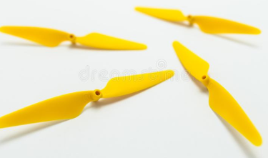

Figure 7: Plastic Propellers

##### 3.2.2.1.2 Existing Deign # 2: Aluminum Propellers

Another existing design of propeller is aluminum propeller which is available, these are sharp and heavy propellers comparing to the plastic propellers while these propellers uses in the water specifically to move the boats. These propellers can also use in our project.

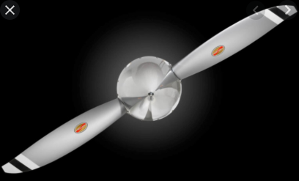

Figure 8: Aluminum Propellers

##### 3.2.2.1.3 Existing Design # 3: Carbon Fiber Propellers

These are the light weight and strong propellers now a days using all type of flying items including drones and small helicopters. These propellers are strong but light weight which make them quite useful and these propellers are the best option to use in this project as well.

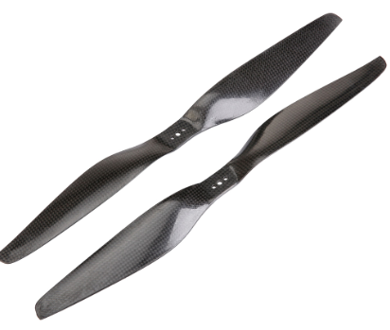

Figure 9: Carbon Fiber Propellers

#### 3.2.2.2 Subsystem # 2: Motors

Motor is one of the most important aspect in this project because motors will use to fly the device, and it will use to move the wipers and it will use to throw the water on the sign board and clean the board. So almost each part of the device contains the motors.

##### 3.2.2.2.1 Existing Design # 1: DC Motor

A simple DC motor is an existing design developed already and it has been using widely in the projects at small level because of their small and compact size. These motors can easily work on the batteries and provide long battery backup because of low power consumption. These are useful for this project as well.

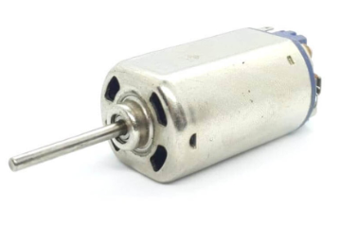

Figure 10: DC Motor

##### 3.2.2.2.2 Existing Design # 2: Stepper Motor

It is also a DC motor but it uses te angles and steps to move in both directions which make it useful where the slow motion and angle motion required from the motor.

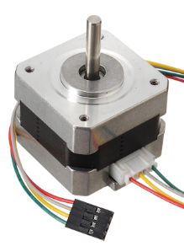

Figure 11: Stepper Motor

##### 3.2.2.2.3 Existing Design # 3: Servo Motor

It is another type of motor which works on DC but it is powerful and high torque generated motors and these motors are widely using in the robotics now and can use in this project as well.

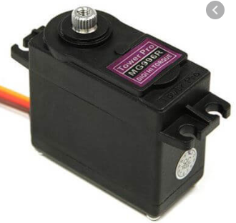

Figure 12: Servo Motor

#### 3.2.2.3 Subsystem # 3: Microcontroller

This is another subsystem in this project and it will use to control the complete project. Microcontroller will take the instructions from user and will act accordingly. All the motors will control through the microcontroller so it will be main part of this project.

##### 3.2.2.3.1 Existing Design #1: Arduino Controller

Arduino is a package which has each part connected over a single chip and this can use in the project as a main controller and no need to connect another controller or driver circuits to make it working. This whole chip can code through C language or Arduino built in language available online.

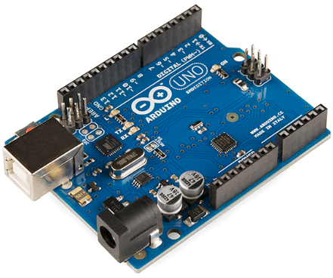

Figure 13: Arduino Controller

##### 3.2.2.3.2 Existing Design #2: Raspberry Pi Controller

This is another available controller to use similar to the Arduino with other features like built in double USB ports, fully operational and it can easy to mount in small products without doing lot of efforts to resolve the problem. This can also use in this project.

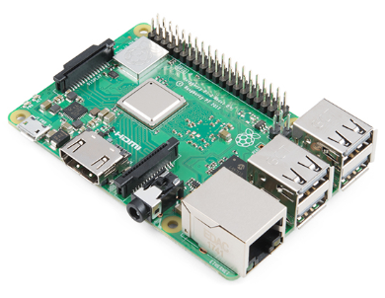

Figure 14: Raspberry Pi Controller

##### 3.2.2.3.3 Existing Design #3: BeagleBoard

This is another existing design for the controller and it is a low power consumption board in which the device will operate using the low power and it is also an open source module to use in this project.

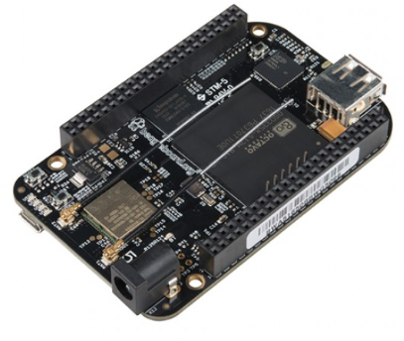

Figure 15: BeagleBoard

# 4 CONCEPT GENERATION

In this section the concept generated for the project will present, for the complete design as well as for the subsystems. From these fully generated design the final design will select in the next section using different criteria and methods.

## 4.1 Full System Concepts

The full system concepts are the concepts of complete project and these concepts have generated using the head storming. The ideas generated here will use in the next section for the final selection.

### 4.1.1 Full System Design # 1: RC Controller with Drone

This design consists of a drone with the hanging wire to hang the water bucket and it will control through the RC remote and it will fly in the air to reach to the location and clean the sign board using the moving wiper which will dip into the bubble water and then wipe the sign board to clean it.

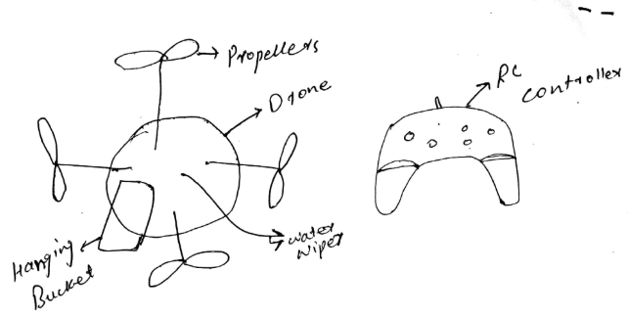

Figure 16: RC controller with Drone

Pros:

* No traffic flow disturbs
* Easy approach
* Safe to use
* No water will drop out

Cons

* Difficult to move in the storms

### 4.1.2 Full System Design # 2: Automatic cleaning Board

This is a device that need to fit on the sign board and it will automatically move from one end to the other end without taking any help. It will clean the board and then it will remove from the board using the support.

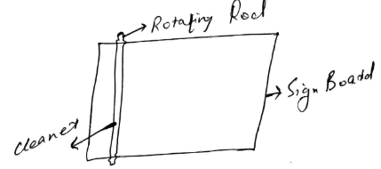

Figure 17: Automatic Cleaning Board

Pros

* Quick service
* Quality cleaning

Cons

* Traffic may disturb in attaching or removing the system

### 4.1.3 Full System Design # 3: Rotating Drone with Firefighter setup

This system is similar to the drone with the automatic control and it has the firefighter setup which throw the water directly to the sign boards from little distance and it will clean the boards.

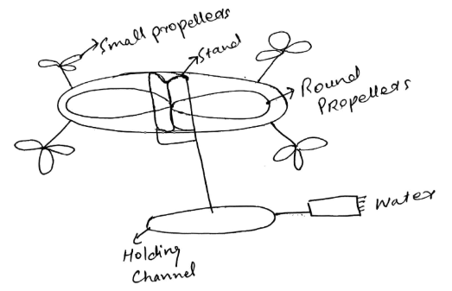

Figure 18: Firefighter setup drone

Pros

* Quick Service
* High performance
* Quality Cleaning

Cons

* Water can split on road when operate not carefully

## 4.2 Subsystem Concepts

In this section subsystem concepts generated for the parts will present and it will use to select the best option that will use in the project. These are the same subsystems defined in the state of art section previously and existing designs have presented for them.

### 4.2.1 Subsystem #1: Propellers

#### 4.2.1.1 Design #1: Two Straight Propellers

In this design the straight propellers have generated, these are two propellers connected from the middle.

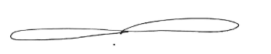

Figure 19: Two straight propellers

Pros

* Sharp
* Light weight

Cons

* Thrust will be less

#### 4.2.1.2 Design #2: Three Propellers

In this design three propellers interlinked from the center

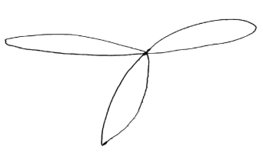

Figure 20: Three propellers

Pros

* High Thrust

Cons

* Heavy weight

#### 4.2.1.3 Design #3: Round Three Propellers

A round circle in which three propellers have connected together to lift the drone up.

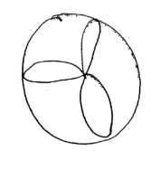

Figure 21: Round three propellers

Pros

* High Thrust

Cons

* Heavy weight
* Not sharp

#### 4.2.1.4 Design # 4: Rim Propellers

The shape of propeller is like the wheel, and it can rotate in the same way to generate the thrust

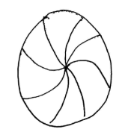

Figure 22: Rim Propellers

Pros

* High trust

Cons

* Heavy weight
* Not sharp

#### 4.2.1.5 Design #5: Single Propeller

A leaf shape propeller to rotate along with the other propeller connects from the same point.

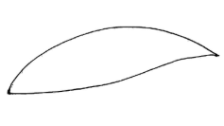

Figure 23: Single Propeller

Pros

* Light weight

Cons

* Small thrust

### 4.2.2 Subsystem #2: Motor

#### 4.2.2.1 Design #1: Square motor

The design is simple a square form in which a rotor is standing at one side of the box for rotation purpose.

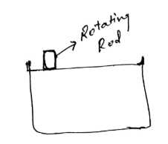

Figure 24: Square motor

Pros

* High speed

Cons

* Heavy in weight

#### 4.2.2.2 Design # 2: Round Motor

It is a round motor in which a rotor has placed at the front side

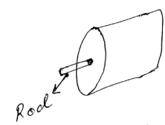

Figure 25: Round Motor

Pros

* Light weight

Cons

* Low speed

#### 4.2.2.3 Design #3: Two rods round motor

Two rods are present in the round motor.

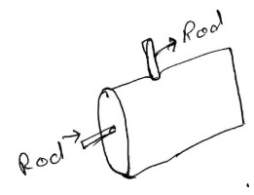

Figure 26: Two rods round motor

Pros

* Double rotation

Cons

* Low speed

#### 4.2.2.4 Design #4: Square Two Rods motor

This is a square motor with two rods on it.

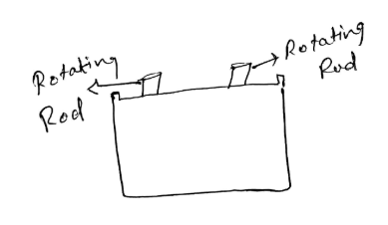

Figure 27: Square Two Rods Motor

Pros

* Double Rotation

Cons

* Low speed
* Heavy weight

#### 4.2.2.5 Design #5: Square box motor

It is a square box shape motor.

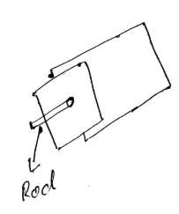

Figure 28: Square box motor

Pros

* High speed

Cons

* Heavy weight

### 4.2.3 Subsystem # 3: Microcontrollers

#### 4.2.3.1 Design #1: Chip controller

It contains only the microchip and it need the drivers separately to run.

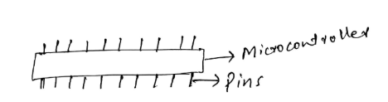

Figure 29: Chip controller

Pros

* High Speed

Cons

* Need drive circuits

#### 4.2.3.2 Design # 2: Double Chip Controller

This controller contains two chips to make the operation fast and it contains built in circuitry.

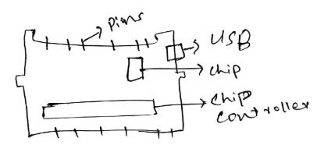

Figure 30: Double Chip controller

Pros

* High speed
* Circuitry available

Cons

* Costly

#### 4.2.3.3 Design # 3: Single Chip Controller

This control has one microchip with all the circuitry install over it.

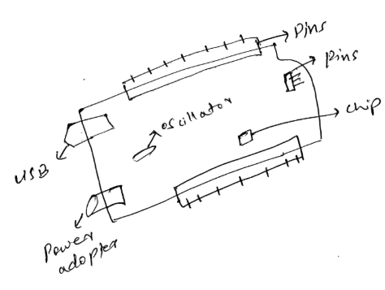

Figure 31: Single Chip controller

Pros

* Economical
* Circuitry available

Cons

* Low speed

#### 4.2.3.4 Design # 4: Two ways controllers

This controller contain the chip connect in two parts which can get separate as well.

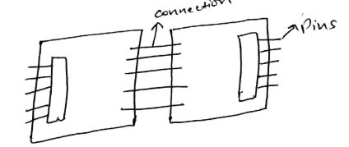

Figure 32: Two Ways Controllers

Pros

* Two Controllers
* Circuitry available

Cons

* Costly

#### 4.2.3.5 Design #5: Simple Chip with circuitry

This controlled contain a chip with USB and power adopter without the microcontroller, it will install the microcontroller over.

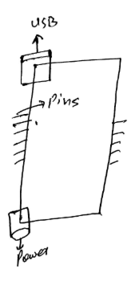

Figure 33: Simple Chip with Circuitry

Pros

* Economical

Cons

* Low Speed
* Chip not available

# 5 DESIGNS SELECTED

In chapter 5, it state that the way to select any design for the design project depends on the criteria which evaluate the generated concepts on equal basis and these type of methods includes Pugh chart, and decision matrix. Through these methods, we can easily evaluate multiple design and then narrow down the result to get the final solution.

## 5.1 Technical Selection Criteria

In order to select the designs using the method, it has devised to use Pugh chart which narrow down the results from top three to top two and then use the decision matrix to select the final design. The top design will evaluate through the back of envelop equations. The criteria for the Pugh chart is customer requirements and the criteria for the decision matrix is engineering requirements.

## 5.2 Rationale for Design Selection

The two methods which will use to select the final design have stated below

**Pugh chart**

It is a chart which check each design with the customer requirement and see if the requirement is fulfilling by the design or not, if not then put negative sign, and if yes then put the positive sign. Then adds up the positive and negative signs to see which design got the highest positive signs. In this way the top two design will select.

Table 3: Pugh Chart

|  |  |  |  |  |  |
| --- | --- | --- | --- | --- | --- |
| TRAFIC SIGN CLEANER | Weight | Firefighters Drone | RC Controller with Drone | DATUM | Automatic Board |
| Do not interrupt the flow of traffic | 9 | + | + | D | + |
| Failsafe | 8 | + | + | D | - |
| Collect Water Drops | 7 | + | + | D | + |
| Clean in short time | 6 | + | + | D | + |
| Clean without damaging the coating | 5 | + | + | D | + |
| Safe to Operate | 4 | + | - | D | - |
| Cost within budget | 3 | + | + | D | + |
| Durable and Robust Design | 2 | + | - | D | - |
| Reliable Design | 1 | + | + | D | - |
| Pluses |  | 9 | 7 | - | 5 |
| Minus |  | 0 | 2 | - | 4 |
| Total |  | 9 | 5 | - | -1 |

The top two designs are

1. Firefighter Drone
2. RC Controller Drone

Now move to the Decision matrix

**Decision Matrix**

It will multiply the weightage with the raw number for each requirement against each design and then will add up the numbers to see the highest marks and that will be the final design.

Table 5: Decision Matrix

|  |  |  |  |  |  |  |  |
| --- | --- | --- | --- | --- | --- | --- | --- |
| Decision Matrix | Flight Time | Height of Flight | Water Tank | Device Weight | Reliable in Temperature | Durable | Total |
| Weight | 6 | 5 | 4 | 3 | 2 | 1 |  |
| Firefighter Drone | 6x6=36 | 4x5=20 | 6x4=24 | 6x3=18 | 4x2=8 | 5x1=5 | 111 |
| RC Controller Drone | 3x6=18 | 2x5=10 | 4x4=16 | 3x3=9 | 2x2=4 | 2x1=2 | 59 |

From the above results it is clear that the best option to use is firefighters drone, because of high advantage over the RC controller drone, as firefighter drone has the high capability of carrying the water and it can easily clean the sign boards without getting imbalance.

# 6 REFERENCES

[1] B. Marian, “Investigation of hydraulic fitting losses”, available [online], <https://www.researchgate.net/publication/325338468_Investigation_of_hydraulic_fitting_losses>

[2] M. Santosh, “Compartive study for Wiper Control System Using MATLAB”, available [online], <https://www.researchgate.net/publication/335524435_Comparative_Study_for_Wiper_Control_Systems_using_MATLAB_Tools>

[3] P. Imade, “Design, Production, and Testing”, available [online], <https://www.researchgate.net/publication/320244094_Design_Production_and_Testing_of_a_Single_Stage_Centrifugal_Pump>

[4] B. Mohammed”, Power Supply Architectures for Drones”, available [online], <https://www.researchgate.net/publication/336669179_Power_Supply_Architectures_for_Drones_-_A_Review>

[5] L. Leo, “Working Principle of Arduino and its tools”, available [online], <https://www.researchgate.net/publication/326316390_WORKING_PRINCIPLE_OF_ARDUINO_AND_USING_IT_AS_A_TOOL_FOR_STUDY_AND_RESEARCH>

[6] D. Alexendar, “Design and Analysis Method FOR UAV Rotor Blades”, available [online], <https://www.researchgate.net/publication/319384839_DESIGN_AND_ANALYSIS_METHODS_FOR_UAV_ROTOR_BLADES>

[7] D. John, “Traffic Sign Cleaner Visionclean”, available [online], <https://www.r-italia.it/en-us/traffic-sign-cleaner-visionclean/>

[8] BBC, “Clearning Signs Manually”, available [online], <https://www.bbc.com/news/uk-england-nottinghamshire-47668406>

[9] I. Mart, “Solar Cleaning Boards”, available [online], <https://www.indiamart.com/proddetail/automatic-solar-panel-cleaning-14748345333.html>

[10] J. George, “Plastic Propellers”, available [online], <https://www.dreamstime.com/yellow-plastic-propellers-quadcopter-drone-isolated-white-background-image137056235>

[11] F. John, “Aluminum Propellers”, available [online], <https://hartzellprop.com/products/propeller-systems/aluminum-propellers-piston-engine-aircraft/>

[12] G. Man, “Carbon Fiber Propellers”, available [online], <http://www.helipal.com/tarot-1455-carbon-propellers-two-holes-cw-and-ccw.html>

[13] C. Mos, “DC MOTOR”, available [online], <https://circuit.rocks/dc-motor-480-rare-earth.html>

[14] F. Kala, “Stepper Motor”, available [online], <https://www.banggood.com/42mm-12V-Nema-17-Two-Phase-Stepper-Motor-For-3D-Printer-p-1164619.html>

[15] H. Fine, “Servo Motor”, available [online], <https://www.jsumo.com/mg996r-servo-motor-digital>

[16] T. Temo, “Arduino”, available [online], <https://learn.sparkfun.com/tutorials/what-is-an-arduino/all>

[17] R. Bi, “Raspery Bi”, available [online], <https://www.sparkfun.com/products/14643>

[18] T. Roy, “Beagboard”, available [online], <https://w11stop.com/beaglebone-black-wireless>

# 7 APPENDICES

